Introducing the KHANGA Spreadsheet
Elsbeth Court in partnership with the Centre of African Studies, SOAS
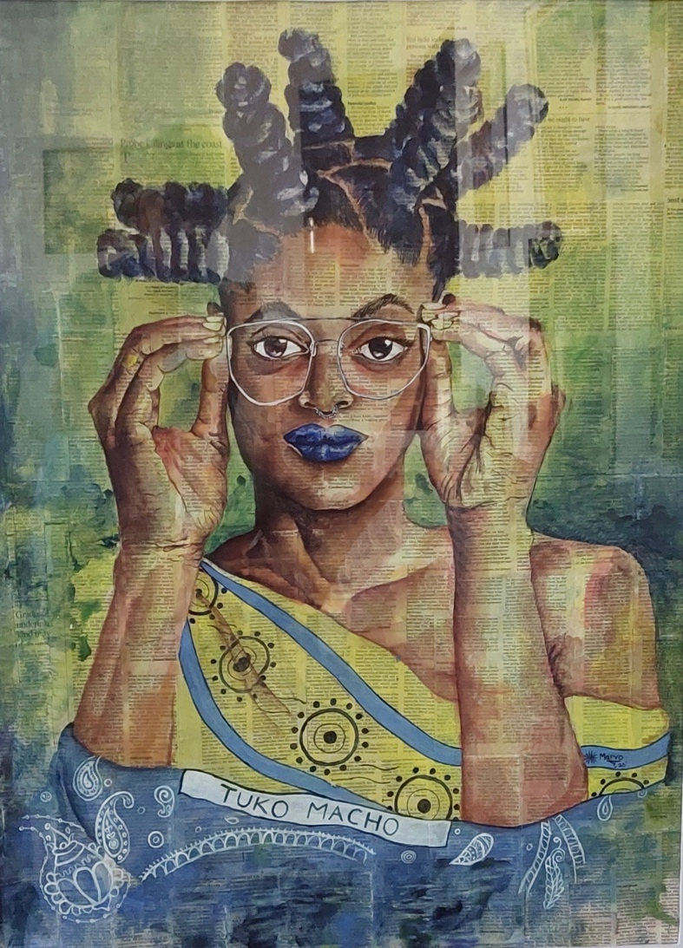
TUKO MACHO by Marvin Abwao, 2021, paint on newspaper
[Courtesy of the artist; Collection: Ruth & Donald Thomas, Nairobi]

This Kenyan student’s painting of a young woman wrapped in a kanga/khanga that bears the Swahili inscription Tuko Macho “we are watching” sets the tone for this spreadsheet. Abwao’s depiction indicates a respect for tradition by youths “who grew up learning from the sayings written on kanga that our mothers adorn”. His invented proverb alerts the older generation that youths are watching them, “seeing what they are doing to our surroundings and the lies they tell” (e-mail: M. Abwao, 2.10.22). For me, Tuko Macho is also watching us -- we in the North who study, teach, interpret and/or appropriate African art and languages: how are we re-presenting continental cultures?

The key objective of the Khanga Spreadsheet is to stimulate further, wholistic consideration of kanga as an aesthetic tradition that was initially practiced by east African women. Its secondary aims are to create awareness (1) about the expansion of kanga in terms of its imagery and usage throughout eastern and southern Africa (Clarke:2005; Spring:2012) and (2) about its incorporation into the practices of contemporary creatives – artists and designers.

KANGA (singular/plural) are east Africa’s iconic printed textiles that were devised in the late 1860’s in Mombasa and Zanzibar on the coast of the Indian Ocean. Its earliest formats were a rectangular length composed of six identical, Portuguese handkerchiefs (called leso, the name still preferred on the Kenya coast) and a block printed black on white cotton rectangle. To onlooking men, socializing women wrapped in these black and white prints resembled a gregarious flock of guinea fowl, called ‘kanga’ in Swahili - thence the cloth’s name. The wearing of these printed textiles bestowed status and was associated with the emancipation of enslaved women (Fair:2001).

By 1900, the standard format of kanga had evolved to comprise a central graphic image/s (Swahili: mji for village or compound), a complementary frame or edge (Swahili: pindo ) and an inscription or saying (Swahili: msemo) that is located in the mji. The composition is symmetrical, employing diverse kinds of imagery that is often a mixture of conventional motifs and figuration in a rectangle (1 metre height by 1.5 metres width). The designs are printed in two or three bright, contrasting colours on soft, thin cotton (indeed, an important attribute is the feel of the cloth). By the 1920’s, kanga were manufactured in European and Indian textile mills (Ryan, 2018).and since Independence also in local factories. The combination of a culturally-relevant format, mass-production and wide distribution has kept kanga accessible and popular despite changing dress codes -- and second-hand clothing.

The catalogued collection of fifty kanga – those on the spreadsheet – are, I estimate, about a third of the total I had acquired since 1966 (based upon my photographs and those of other collections). Some kanga wore out, others were lost or stolen; many were given as presents and donations (to the British Museum). Indeed, my collection is tiny given the massive volume of kanga manufacture and trade. Nonetheless, it, like the collections of other women, has a story to tell; indeed, a positive outcome of this project would be to share collections and their narratives.

The spreadsheet provides basic information for each kanga by means of a comprehensive range of variables, most of which follow the object descriptors used by British Museum. Following a small photo of the kanga, eight categories provide facts about its dimensions, kind of cotton, manufacturer (location), acquisition (location, date, by whom) and whether it is “first or second hand”. Three categories describe the kanga’s appearance: colours and kinds of imagery used for the frame/pindo and centre/mji. Four categories refer to the inscription /msemo: its presence, language, translation and theme. A final category is for particular ‘Notes’.

The initial coding was carried out in autumn 2021 with the assistance of Angelica Baschiera, a Swahili specialist and Manager of SOAS Centres and Institutes; it was completed during August 2022. The inscriptions were vetted and discussed by SOAS Swahili language lecturers: Dr Ida Hadjivayanis and Dr Adam Rodgers – their comments are indicated on the Spreadsheet by small red triangles. The Spreadsheet was uploaded to the CAS website page prior to its announcement at Baraza, Swahili Study Day. While there is no particular way to use the Spreadsheet data, researchers/teachers/students are encouraged to explore several of the categories in order to make observations and comparisons. Your feedback is welcome: does the Spreadsheet facilitate a wholistic understanding of kanga? Do you want to know more about kanga?

There are many brief introductions to kanga (usually with many, seemingly random photographs of the textiles, not unlike the Khanga Spreadsheet) and a few excellent, focussed studies on particular topics, such its origins, manufacturers, uses and inscriptions. There are very few studies concerning its designs and designers. As yet there is no definitive or comprehensive treatment of kanga. The selected references, below, from different perspectives and formats provide context for understanding kanga.

In Kenya and Tanzania, a popular subject for many photographers and painters continues to be a woman or women wearing kanga. What has changed in the last decade is the artist’s increased attention to kanga as the focus or object of their work, see for example, Abwao’s Tuko Macho (above), Ziddi Msangi (Tanzanian-American), Lawrence Lemaoana (South African). In contemporary practices, characterized by installation, performance and/or film media, artists have made more extensive transformations to kanga, for example, the work of Lubaina Himid RA (b. Zanzibar) and Rehema Chachage (Tanzanian). Please check the internet for the websites of these artists.

SELECTED REFERENCES
Two websites
The National Museums of Kenya for Google Arts and Culture provides an excellent introductory video that covers history, culture and fashion: ‘Kanga: A Cloth that Unites’:
https://artsandculture.google.com/story/kanga-a-cloth-that-unites/fwLSRgiEQNcJLA
British Museum Collection, on-line catalogue cites some 80 kanga (note a few lack translations for their inscription):
https://www.britishmuseum.org/collection/search?object=kanga

If you can visit in person, the British Museum has a dedicated display of kanga in its Africa Galleries (Room 25) and one in the Well-Being Gallery (ground floor).

Printed texts
Abdela, Farouque. 2008. Mimi Kama Kanga, Nafa na Uzuri Wangu, I am like a Kanga Cloth, I Die in all my Beauty. In M. Arnold, ed. Art in Eastern Africa. Dar es Salaam: Mkuki na Nyota Publishers, 2008. [In the same volume, see N. Merinyo’s chapter on use of kanga in fashion.]
Checinski, Christine., ed. Africa Fashion. London: V & A Publishing. [kanga in the context of Global Africa.]
Clarke, Simon. 2005. The Politics of Pattern: Interpreting Political and National Iconography on kanga cloth. In Hassan Arero & Zachary Kingdon, eds. East African Contours: Reviewing Creativity and Visual Culture. London: Horniman Museum.
Court, Elsbeth & Mwangi, Michael.1976. Maridadi Fabrics. African Arts. 10 (1).

Fair, Laura. 2001. Chapter 2: Dressing Up: Clothes, Class and Gender in Post-Abolition Zanzibar. In Pastimes & Politics Culture, Community and Identity in Post-Abolition Zanzibar,1890-1945. Oxford: James Currey.

Linnebuhr, Elisabeth. 1992. Kanga: Popular Cloths with Messages. In Werner Graebner, ed., Sokomoto. Popular Culture in East Africa. Matatu 9. [Linnebuhr’s 1994 German-language catalogue on kanga for Linden-Museum Stuttgart is my favourite catalogue (of many such booklets) because of her selection of kanga and contextual documentation. The on-line catalogue for the Linden-Museum does not indicate any kanga -- query the current location of Linnebuhr’s collection?]
Parkin, David J. 2003. Textile as Commodity, Dress as Text: Swahili kanga and Women’s Statements. In Ruth Barnes, ed. Textiles in Indian Ocean Societies. New York: Routledge.
Ryan, MacKenzie Moon. 2018. The Art of the Trade: Merchant and Production Networks of Kanga Cloth in the Colonial Era. In Prita Meier & Allyson Purpura, eds. World on the Horizon Swahili Arts Across the Indian Ocean. Champaign, Illinois: Krannert Art Museum. [Check on-line for additional articles by Ryan, who has published extensively on kanga history.]
Spring, Chris. 2012. African Textiles Today. London: British Museum Press. For the regional expansion of kanga, see chapter ‘ Kanga, capulana and shweshwe: printed cloth of eastern and southern Africa’. [This book is associated with the permanent display of kanga in the Africa Galleries of the British Museum and the BM’s Collections. Check on-line for additional articles by Spring, specifically on kanga and on the association between African textiles and modern art.]
Wellon, Michael, ed. 2021. LUBAINA HIMID. Exhibition catalogue. London: Tate Publishing.
Author’s notes
The impetus for the Khanga Spreadsheet was the Victoria & Albert Museum’s exemplary, introductory exhibition Africa Fashion which includes kanga (on view until 16 April 2023). However, my varied engagement with textiles in East Africa is longstanding, dating back to the mid-1960’s when I was a teacher in Tanzania. My involvement includes personal use, academic use (in teaching and research) and participation, both as a creator of textiles and as a volunteer with Maridadi Fabrics, a women’s screen-printing textile project in Nairobi (Court & Mwangi:1976).

My grateful thanks to Angelica Baschiera for her encouragement and assistance with this project and for her management of the SOAS & V+A series of artists’ talks: Africa Fashion Expanded. Asanteni sana pia - many thanks also to Dr Ida Hadjivayanis, Dr Adam Rodgers and Marvin Abwao for their contributions

Elsbeth Joyce Court
<ec6@soas.ac.uk>
19 November 2022

